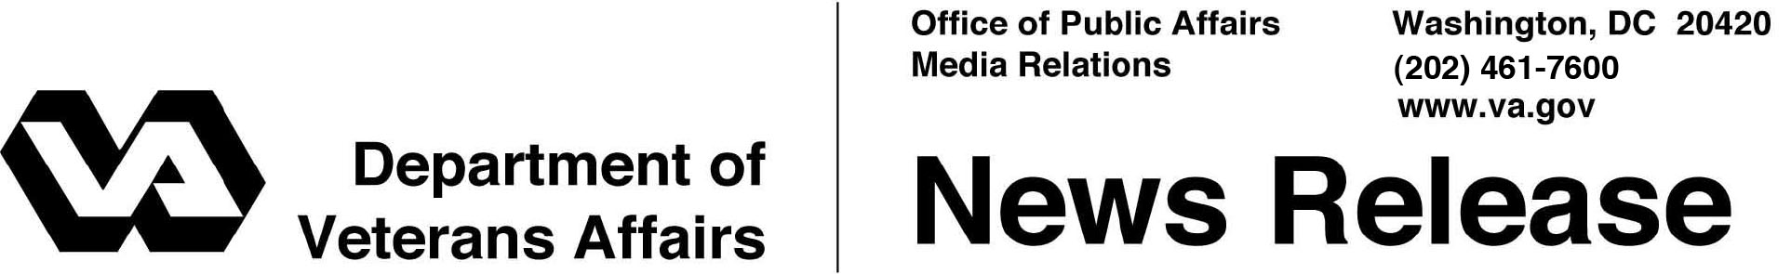

FOR IMMEDIATE RELEASE
April 23, 2013

VA Launches Hotline to Answer Questions on VA Health Care and Benefits for Women Veterans
1-855-VA-WOMEN (1-855-829-6636)
WASHINGTON – The Department of Veterans Affairs has launched a new hotline — 1-855-VA-WOMEN — to receive and respond to questions from Veterans, their families and caregivers about the many VA services and resources available to women Veterans. The service began accepting calls on March 27, 2013.
“Some women Veterans may not know about high-quality VA care and services available to them,” said Secretary of Veterans Affairs Eric K. Shinseki. “The hotline will allow us to field their questions and provide critical information about the latest enhancements in VA services.”
The hotline is staffed by knowledgeable VA employees who can provide information about benefits including health care services for women. Callers can be linked to information on claims, education or health care appointments as well as information about VA cemeteries and memorial benefits. Staff can answer urgent questions and provide referrals to homeless and mental health services as well as provide Vet Center information.
Women make up nearly 15 percent of today’s active duty military and 18 percent of National Guard and Reserve forces. The population of women Veterans using VA benefits including health care is growing rapidly. Since 2000, the number of women using VA health care more than doubled, from nearly 160,000 in 2000 to more than 354,000 in 2012. Based on the upward trend of women in all branches of service, the number of women Veterans—and female VA users—will keep climbing.

VA is committed to making improvements for the growing population of women Veterans, including the way it communicates with them. In 2010, VA established an outbound call center to contact women Veterans and encourage them to enroll in VA health care.
“In VA health care alone, women constitute only 6 percent of VA patients, but those Veterans have a high perception of the quality care they are receiving,” said Irene Trowell-Harris, director of VA’s Center for Women Veterans.
“Many women who served don’t self-identify as Veterans and therefore don’t think they qualify for VA benefits. We need to correct existing misinformation and misperceptions so we can serve more women Veterans with the benefits they’ve earned.”
Women Veterans are entitled to apply for the same benefits as their male counterparts, which include health care and pharmacy benefits as well as education benefits, disability compensation, home loans, employment assistance and more.
The hotline (1-855-VA-WOMEN) joins numerous other VA hotlines that provide critical information and assistance to Veterans, such as those for Veterans in crisis and in danger of becoming homeless. Veterans can also receive information and apply for benefits online at VA’s www.eBenefits.va.gov and manage their health care at MyHealtheVet.va.gov.

###

